**SQL Server Samples in Github**

[**https://github.com/Microsoft/sql-server-samples/tree/master/samples**](https://github.com/Microsoft/sql-server-samples/tree/master/samples)

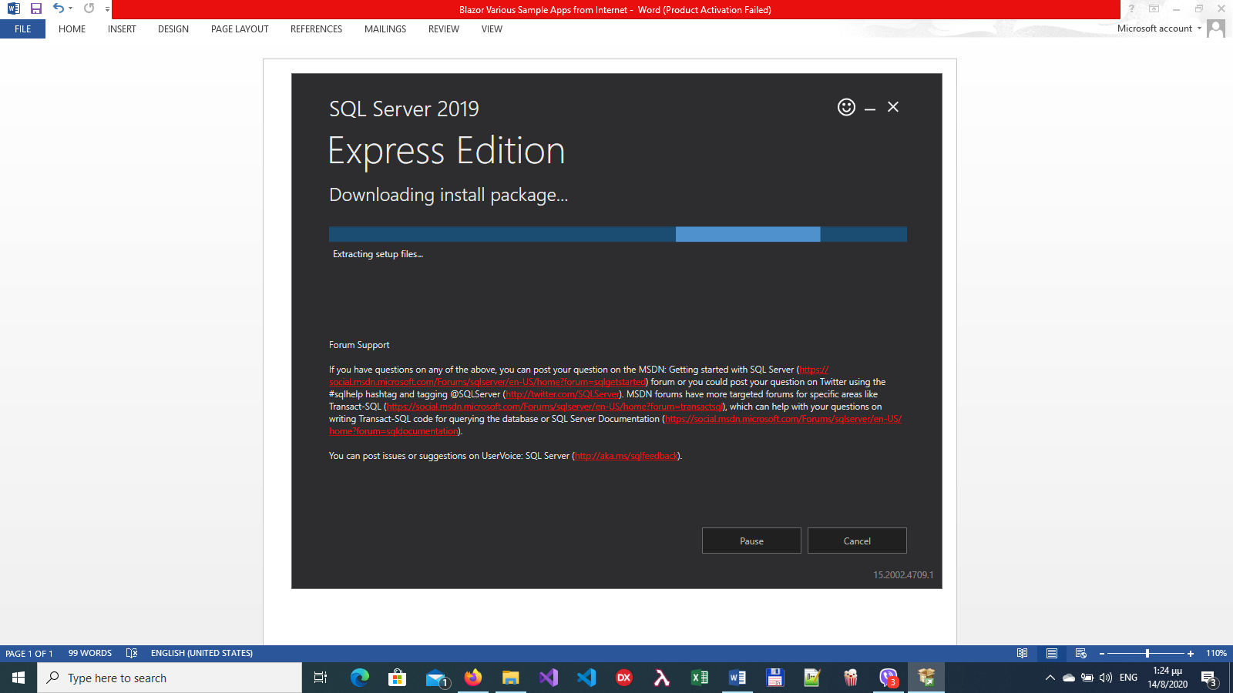

**Blazor Various Sample Apps from Internet**

1. [**https://dev.to/bradwellsb/i-created-some-fi-re-calculators-using-blazor-webassembly-opi**](https://dev.to/bradwellsb/i-created-some-fi-re-calculators-using-blazor-webassembly-opi)

**Sample App is in folder blazor-fire-calculators-master**

1. [**https://www.c-sharpcorner.com/article/create-a-simple-blazor-server-application-with-net-core-3-0/**](https://www.c-sharpcorner.com/article/create-a-simple-blazor-server-application-with-net-core-3-0/)

In this post, we have seen how to create a simple Blazor server app using .NET Core 3.0 SDK with default Blazor template. We have created a service for getting latest post details from C# Corner RSS feeds and showed the data on a razor component.

**Sample App is in folder BlazorSample**

1. [**https://www.c-sharpcorner.com/article/create-a-single-page-app-with-blazor-server-and-entity-framework-core-3-0/**](https://www.c-sharpcorner.com/article/create-a-single-page-app-with-blazor-server-and-entity-framework-core-3-0/)

**Create a Single Page App with Blazor Server and Entity Framework Core 3.0**

# Blazor CRUD with Entity Framework Core – Detailed Tutorial

[**https://www.codewithmukesh.com/blog/blazor-crud-with-entity-framework-core/**](https://www.codewithmukesh.com/blog/blazor-crud-with-entity-framework-core/)